META SQL Interview Questions

Q. We have the table MatchResults with columns: Team1, Team2, Winner.
Now we want:
- Matches played by each team
- Matches won by each team
- Matches lost by each team
- Total points earned (2 points per win)
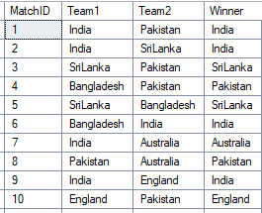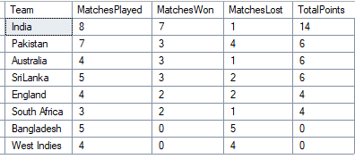

Output:

